An LSTM based Deep Learning Model for Vehicle Traffic Flow Prediction

Introduction:

In Intelligent transportation systems, the traffic flow prediction is fundamental problem for transportation modelling and management. Traffic flow prediction plays a key role in intelligent transportation systems. Without accurate traffic flow prediction, none of the intelligent transportation systems could work well. Literature shows lot of research focused on this problem and they classified prediction approach into three categories viz., time series approach with ARIMA model for finding patterns of traffic flow and use that pattern for prediction, probabilistic approach for modelling and forecasting from probabilistic perspective and finally non-parametric approaches which performed better due to their capability of handling un-deterministic and complex time series traffic datasets.

In our research we will use California department of transportation (Caltrans) data set. Caltrans Performance Measurement System (PeMS) provides data collected in real-time from over 39,000 individual detectors. These sensors span the freeway system across all major metropolitan areas of the State of California. PeMS is also an Archived Data User Service (ADUS) that provides over ten years of data for historical analysis. In this study, our main objective will be to study and analyse the historical traffic data available in PeMs dataset. Further, our study focuses on the traffic prediction model at any time interval using Long short-term memory (LSTM) networks. The result of this study can predict and forecast the traffic flow during peak hours and non-peak hours for a particular city. Further, we compare our LSTM model with other baseline models and exhibit the prediction accuracy of our new model over the existing models.

**Long Short-term Memory (LSTMs):**

**Long short-term memory** (**LSTM**) is an artificial [recurrent neural network](https://en.wikipedia.org/wiki/Recurrent_neural_network) (RNN) architectureused in the field of [deep learning](https://en.wikipedia.org/wiki/Deep_learning). Unlike standard [feedforward neural networks](https://en.wikipedia.org/wiki/Feedforward_neural_network" \o "Feedforward neural network), LSTM has feedback connections and it can not only process single data points, but also entire sequences of data (such as speech or video). LSTM networks are well suited for the data which was collected over a time period at regular intervals of time which was known as Time-series data.

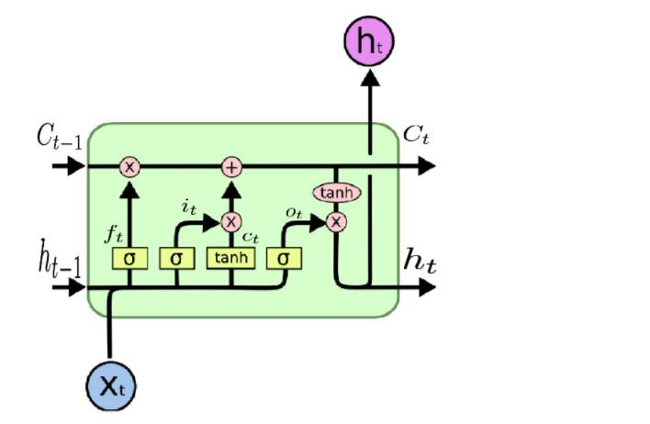

Fig. LSTM cell

A common LSTM unit is composed of a **cell**, an **input gate**, an **output gate** and a **forget gate**. The cell remembers values over arbitrary time intervals and the three *gates* regulate the flow of information into and out of the cell.

LSTM networks are well-suited to [classifying](https://en.wikipedia.org/wiki/Classification_in_machine_learning), [processing](https://en.wikipedia.org/wiki/Computer_data_processing) and [making predictions](https://en.wikipedia.org/wiki/Predict) based on [time series](https://en.wikipedia.org/wiki/Time_series) data, since there can be lags of unknown duration between important events in a time series. LSTMs were developed to deal with the exploding and [vanishing](https://en.wikipedia.org/wiki/Vanishing_gradient_problem) gradient problems that can be encountered when training traditional RNNs. Relative insensitivity to gap length is an advantage of LSTM over RNNs, [hidden Markov models](https://en.wikipedia.org/wiki/Hidden_Markov_models) and other sequence learning methods in numerous applications.

**Objectives of our work:**

In this research, our main objective is to analyse the historical time-series traffic data generated from sensors and design an LSTM based traffic flow prediction model using the analysed dataset. Further, compare our model with the other base-line models

**Methodology:**

1. Download the relevant datasets and pre-process the datasets for analysis
2. Design an LSTM model for the time-series traffic dataset.
3. Train the designed / constructed LSTM model with the existing datasets
4. Predict the traffic flow at a particular instance of time using the trained model.
5. Generate the accuracy and compare the performance of the model with other baseline models.